**Fruits, vegetables, and health: A comprehensive narrative, umbrella review of the science and recommendations for enhanced public policy to improve intake**

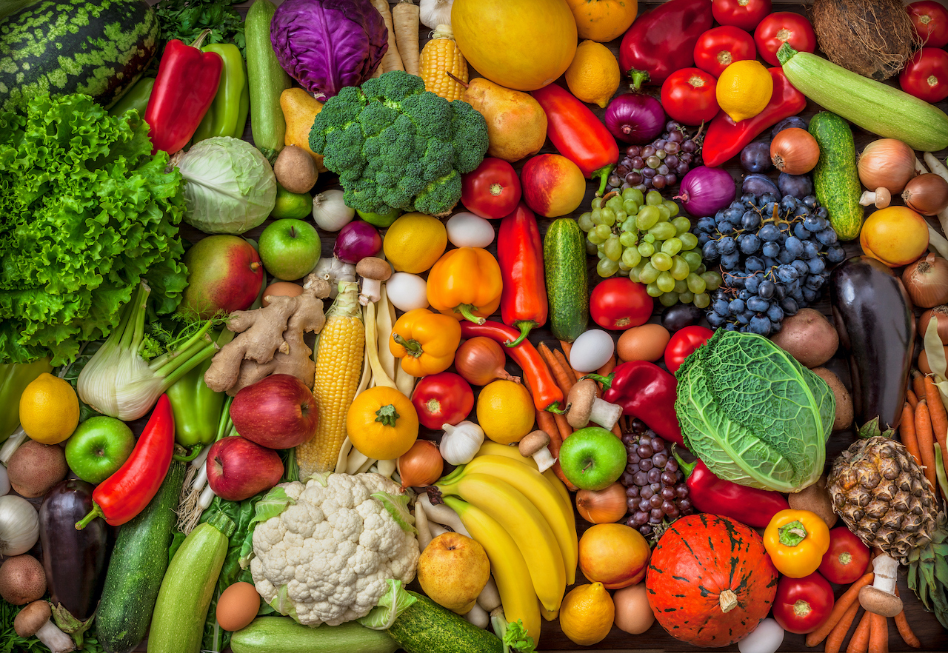

* [**Introduction**](https://www.tandfonline.com/doi/full/10.1080/10408398.2019.1632258#_i3)
* **Effect of fruit and vegetable intakes on all-cause mortality**
* **Effects of fruit and vegetable intake on health outcomes**
* [**Increasing fruit and vegetable consumption**](https://www.tandfonline.com/doi/full/10.1080/10408398.2019.1632258#_i57)
* [**Conclusions**](https://www.tandfonline.com/doi/full/10.1080/10408398.2019.1632258#_i59)

**Introduction**

**Abstra**

Dietary risk factors associated with poor health in the United States are those considered to be low in fruits, vegetables, whole grains, nuts, and seeds and high in refined carbohydrates, added sugars, sodium, and certain saturated fats.

Diets high in fruits and vegetables (F&V) are widely recommended in developed countries for their health-promoting properties; they have historically held a place in dietary guidance because of their vitamin, mineral, dietary fiber, and, more recently, dietary bioactive content.

Most nutritional and global recommendations include consumption of at least 2 servings of fruits and 3 servings of vegetables per day for adults. More than 100 countries worldwide have developed food-based dietary guidelines adapted to their nutrition situation, food availability, culinary cultures, and eating habits that encourage increased F&V consumption.

However, F&V in their harvested consumed form have been shown to vary widely in nutritional contribution, density, and dietary bioactive content of a standard serving.

Eighty-eight percent of countries face a serious burden from two or three forms of malnutrition: acute and/or chronic undernutrition, micronutrient deficiencies, obesity, and diet-related diseases, including type 2 diabetes, cardiovascular diseases, and certain types of cancer.

Thus, dietary guidance over time has consistently supported the principles of moderation and variety.

**Effect of fruit and vegetable intakes on all-cause mortality**

During the past 50 years, lifestyle factors have been identified as modifiable factors associated with premature death.

Despite often unclear direct biological mechanisms, epidemiological risk factors can change the probability of death and can serve as important public health indicators.

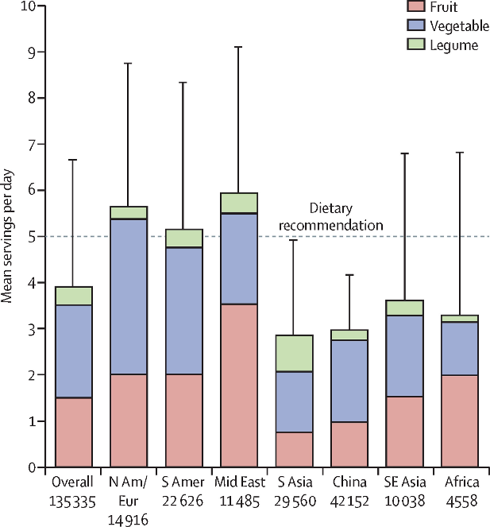 Several dated meta-analyses have shown that obtaining recommended intakes of F&V, among other food groups such as whole grains, nuts, and fish, is one of the most important factors associated with a lower risk of all-cause mortality.

The most recent systematic review and meta-analysis found that with increasing intake, the risk of all-cause mortality decreased for fruits, vegetables, whole grains, nuts, and fish.

Optimal consumption of risk-decreasing foods resulted in a 56% reduction in all-cause mortality.

However, these investigated food groups are often only part of healthy dietary patterns. High adherence to the HEI and Dietary Approaches to Stop Hypertension diets has been associated with a 22% lower risk of all-cause mortality.

**Effects of fruit and vegetable intake on health outcomes**

The literature search strategy identified 401 articles, of which 96 systematic reviews were identified after completion of the title/abstract screening that assessed F&V intake on various disease outcomes.

All 96 studies were included for data extraction after full-text review. Most systematic reviews contained meta-analyses that assessed high vs. low intake of F&V on disease outcomes.

Fewer systematic reviews assessed whether a dose-response relationship existed between the amount of F&V consumed and specific health outcomes.

Various types of cancer and cardiovascular outcomes were the most frequently assessed disease outcome, with other disease states such as type-2 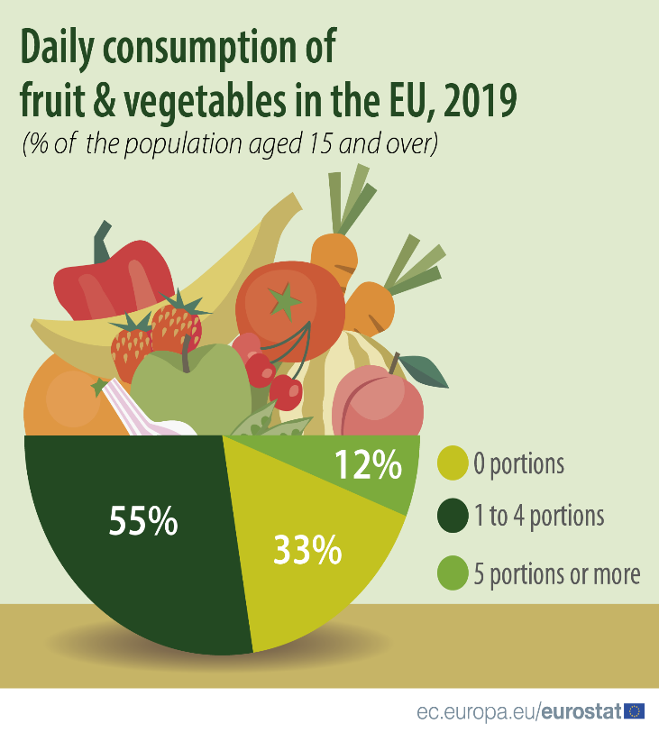diabetes, AMD and osteoporosis, among others, being less common.

As anticipated for assessment of disease outcomes, the majority of systematic reviews included observational data and human interventions studies were scarce.

Results of the individual systematic reviews are discussed in the corresponding disease state sections of this manuscript.

The review was focused on the major global causes of morbidity and mortality: CVD, cancers, infectious diseases, musculoskeletal diseases, and other important health topics.

F&V intakes with regard to contributors to chronic disease including weight status, inflammation, and immunity are also discussed.

**Increasing fruit and vegetable consumption**

F&V are colourful, flavourful, and nutritious components of the diet and are often most attractive when harvested at their peak maturity.

However, most F&V grow only in certain parts of the world, under specific environmental conditions, and at particular times throughout the year.

They also typically contain >90% water and once harvested begin to undergo higher rates of respiration that results in moisture loss, quality deterioration, and potential microbial spoilage.

Storage and processing technologies, such as freezing, canning, drying, and juicing, all serve to transform perishable produce into products that can be consumed year-round.

Processed products such as canned goods may contribute to increased sodium intakes; however, draining brine and/or rinsing vegetables and legumes reduces their sodium content in addition to other water-soluble nutrients like vitamin C.

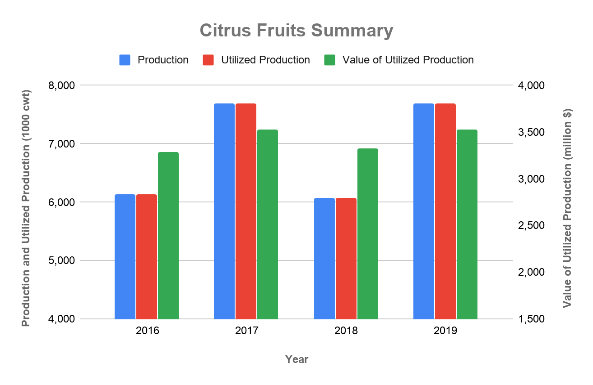

**Conclusions**

Strong accumulating evidence demonstrates that habitual consumption of F&V, primarily of the non-starchy variety, has health-promoting properties that extend beyond helping individuals obtain essential nutrient requirements.

Authoritative bodies have long recommended consumption of F&V because of their low energy density, high nutrient density, and dietary fibre content.

In addition to essential nutrients, it is well established that F&V contain a diverse array of dietary bioactive compounds that provide human health benefits beyond basic nutrition in addition to their essential nutrients.

The majority of evidence linking F&V intake to health promotion and chronic disease prevention is observational and cannot be used to establish causality.

RCTs that are strong in their design and execution have the ability to establish causality but will likely always have the caveat of an insufficient duration to capture disease outcomes.

Moreover, many health benefits chronic conditions are interrelated (e.g., microbiota, inflammation and immune function) giving precedent to conducting research on F&V using a more systems-based approach.

|  |  |
| --- | --- |
| Abbreviations | |
| **AICR** | American Institute for Cancer Research |
| **BMD** | bone mineral density |
| **BMI** | body mass index |
| **CHD** | coronary heart disease |
| **CI** | confidence interval |
| **CKD** | chronic kidney disease |
| **COPD** | chronic obstructive pulmonary disease |
| **CRP** | C-reactive protein |
| **CVD** | cardiovascular disease |
| **F&V** | fruit and vegetable |
| **FAO** | Food and Agriculture Organization of the United Nations |
| **FLAVURS** | Flavonoids and Vascular Function at the University of Reading Study |